解题报告：Counting Rectangles

题目来源：ACM-ICPC Tehran 1999
解法或类型： 计算几何
Counting Rectangles
Time Limit:1S Memory Limit:1000K
Total Submit:90 Accepted:48
Description
We are given a figure consisting of only horizontal and vertical line segments. Our goal is to count the number of all different rectangles formed by these segments. As an example, the number of rectangles in the Figures 1 and 2 are 5 and 0 respectively.
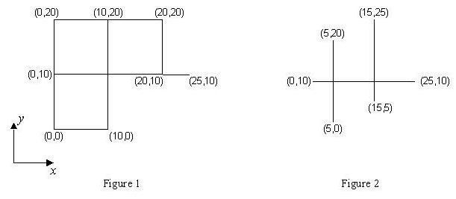
There are many intersection points in the figure. An intersection point is a point shared by at least two segments. The input line segments are such that each intersection point comes from the intersection of exactly one horizontal segment and one vertical segment.
Input
The first line of the input contains a single number M, which is the number of test cases in the file (1 <= M <= 10), and the rest of the file consists of the data of the test cases. Each test case begins with a line containing s (1 <= s <= 100), the number of line segments in the figure. It follows by s lines, each containing x and y coordinates of two end points of a segment respectively. The coordinates are integers in the range of 0 to 1000.
Output
The output for each test case is the number of all different rectangles in the figure described by the test case. The output for each test case must be written on a separate line.
Sample Input
2
6
0 0 0 20
0 10 25 10
20 10 20 20
0 0 10 0
10 0 10 20
0 20 20 20
3
5 0 5 20
15 5 15 25
0 10 25 10
Sample Output
5
0

解题思路：

这是一道很简单的搜索+计算几何题目，题目的意思是给出平面上若干条沿竖直或者水平方向的线段，问它们可以构成多少个矩形，由于题目有一个重要的条件：每个交点又且只有一条竖直和一条水平的线段经过，所以我们可以得到一种很简单的计数法：把所有线段分为水平和竖直的，在水平直线中任选两条，竖直直线中任选两条，假如它们可以形成一个矩形：（如下图）左边是可以的，右边是不可以的。题目转化为不同类型的直线是否两两相交。由于这个题目的特殊性，对于(x1,y)-(x2,y)和(x,y1)-(x,y2)只需判断(y1-y)*(y2-y)<=0
和(x1-x)*(x2-x)<=0就可以了。
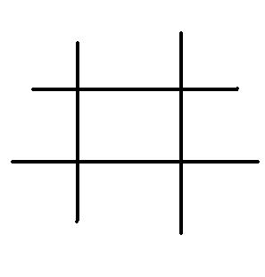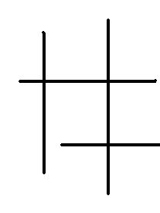

数据结构：

用两个100*4的数组分别保存竖直直线和水平直线，在读入数据的时候就处理。

时空分析：

空间复杂度可以忽略不计。时间复杂度上，分别从水平和竖直直线集合中选出两个元素复杂度为O(n^4)，算法不是很好,但作为这种比赛中的送分题，没有必要花太多的时间在改进时间复杂度上，加上数据有比较大的随机性，所以最后测试结果还是0MS。

源程序：

Acm1693.cpp

